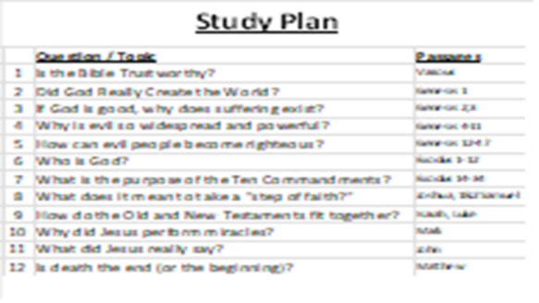 | Here is a schedule of the lessons in this study series. Since it is a very high-level study of the Bible, we call it “Creation to Christ” and abbreviate it as “C2C”.
 | Deep in all of our hearts, we sense that our life has a purpose – a meaning that extends beyond this physical world. Perhaps you have been lying awake at night wondering about this, but eventually, you get discouraged or distracted and try to ignore the biggest questions of life: Where did I come from? Why am I here? What will happen after I die?  I’m glad that you came today as we start a high-level study of the Bible. If you come with an open heart, I believe that you will find this book has answers to all of these questions (and much more). It is a big book - a person can spend a lifetime studying this book. Our lessons will only present an overview of some basic things that the Bible teaches. We will study the Bible chronologically and we will only study selected key events. Once you understand the basics of the Bible, the rest of the Bible is easier to understand.  (Remember – apologetics cannot convince a skeptic to believe, but it can remove some barriers to belief for someone who desires to know the truth.)
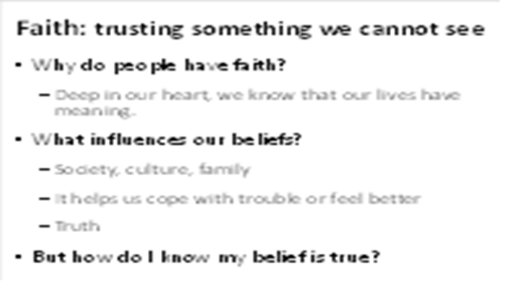 | People all over the world believe that their life has a purpose. If our lives end at the grave, it doesn’t matter whether our life is virtuous or villainous. As Tim Keller says, if you’re on the Titanic as it sinks, it doesn’t matter if you go down hugging or mugging. But deep inside, we all have been created with a greater sense of purpose that continues after we die.  Along the way, people actively choose or passively accept a belief system to live by. Why do people choose one belief system over another? Here are some reasons, but ultimately, what matters most is whether or not their belief system is true.
 | There are many different belief systems, and if you examine them, they are all very different. As such, they cannot all be true. So, how do we identify the one that is true?
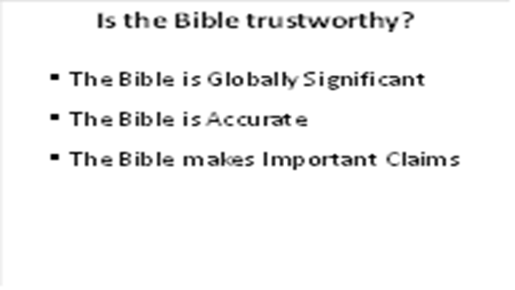 | Perhaps you’ve heard some things about the Bible. Many people think that the Bible is just a book of Legends or that it is like many other religious books – filled with rules and philosophy. Tonight, I want to clarify what the Bible really is and why it’s worth studying.
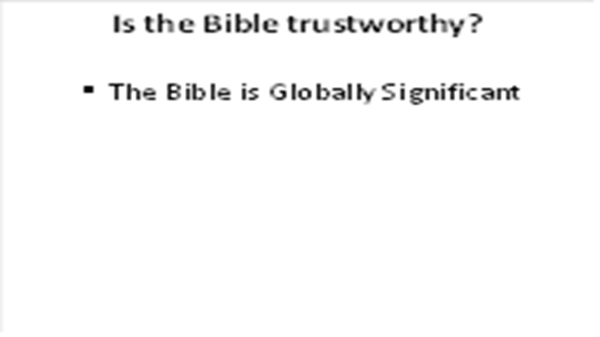 | Perhaps you’ve heard some things about the Bible. Many people think that the Bible is just a book of Legends or that it is like many other religious books – filled with rules and philosophy. Tonight, I want to clarify what the Bible really is and why it’s worth studying.
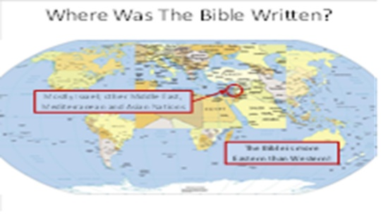 | Some people mistakenly assume that the Bible is western, or that it came from America. It was written thousands of years before America was founded, and it is actually eastern in nature.
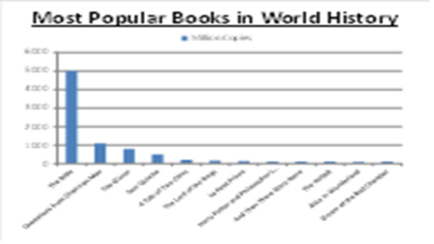 | The Bible was the very first book printed on the first commercial printing press in Gutenberg, Germany (1450AD). For every year since then, it has been the best-selling book globally.  These numbers are as of January 2000 and are only estimates. But it is clear that the Bible is by far the most printed and read book in world history.
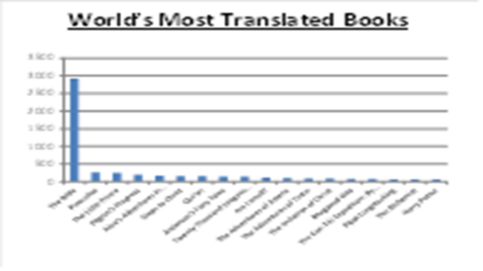 | The global importance of the Bible is clearly shown by the number of languages into which it has been translated. Almost anywhere in the world, people can read the Bible in their own language.
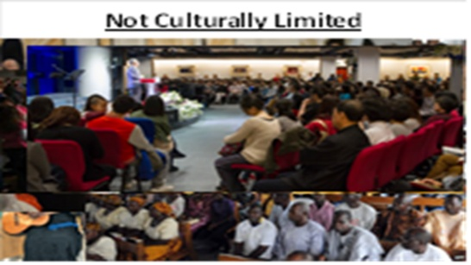 | Unlike most religious books, the Bible is not defined by one specific culture. If a person submits to Islam, they must wear Arabic clothing and read the Quran in Arabic. If a person chooses to be Hindu or Buddhist, they adopt Asian appearance and meditation styles. But when the Bible enters a culture, it doesn’t require people to adopt the clothing or customs of one country – it is a global message for all cultures around the world.
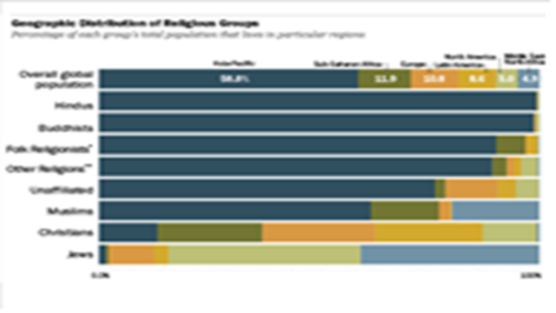 | Most religions tend to remain concentrated in the area where they originated. But look at the bar for Christianity: although it originated in the middle east, that area has the lowest concentration of Christians. And Christians are the only group on the page that have a fairly even distribution around the entire world. It is truly a global faith – exactly what you would expect for a message that was sent by God to the entire world.  Another thought to consider: when I ask a Muslim why he is a follower of Islam, it is always because his family was Muslim of Islam was forced upon his country by other Muslims. If I ask a Hindu or Buddhist why they chose that faith, it is usually because their parents and family follow it. It tends to reinforce the point that religions typically choose people (vs. people choosing religion). But Christianity is different. It doesn’t force people into acceptance, and many followers don’t come from families of Christians – they choose it because in is true.
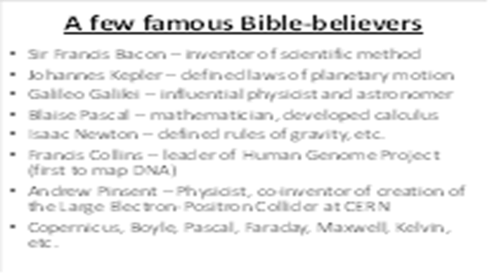 | Some people suggest that the Bible is only accepted by foolish, old, superstitious people. But the fact is, many brilliant scientists and philosophers from the past and the present have studied and accepted the Bible. This demonstrates that a person doesn’t need to ignore the facts to accept the Bible.  But remember that the scientific method is useful but can only effectively study and explain things that observable, measureable, and repeatable. When studying religion*, we need to use the evidentiary method, like a detective seeking clues and looking for consistency of testimony, relevance, authenticity, trustworthiness, etc. *(creation, meaning, love, morality, destiny, etc.)
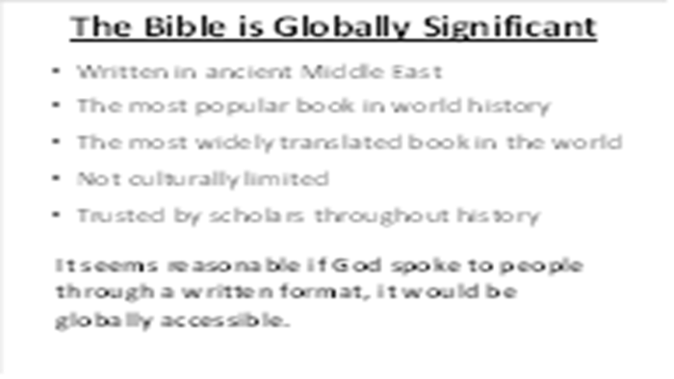 | These are just a few things that demonstrate the importance of the Bible. You may not yet believe that it is the written word of God, but at least you should take some time to understand the message of the most important book in world history. And it seems reasonable that, if God spoke to people through a written format, it would be globally accessible.
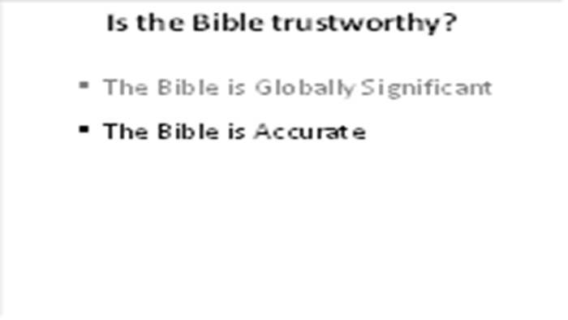 | Perhaps you’ve heard some things about the Bible. Many people think that the Bible is just a book of Legends or that it is like many other religious books – filled with rules and philosophy. Tonight, I want to clarify what the Bible really is and why it’s worth studying.
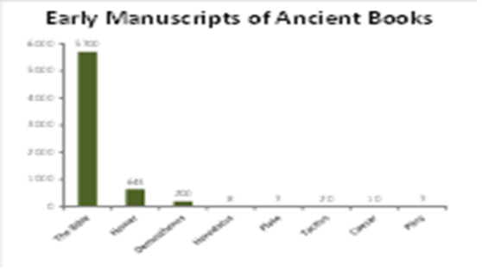 | The Bible is unique among ancient books in that there are so many copies of the original manuscripts in existence. Because of this, we have the ability to compare many original manuscripts to modern translations and assure nothing was lost or added to the original text. (5700 speaks directly about copies of New Testament. Many OT copies exist as well, especially from the Dead Sea scrolls)
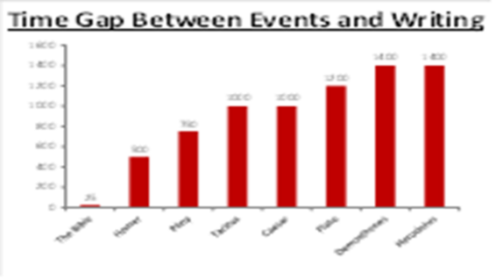 | Many ancient stories were only preserved in the memories of storytellers, allowing them to develop into legends over time. But the Bible is unique: Most of the books were written down by eye-witnesses or by first person interviewers. The prevents the story from being changed over time.
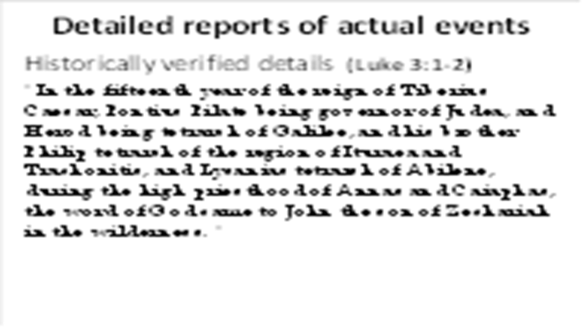 | Not historical fiction! Until about 1800AD, fiction was written with vague details. Instead, the Bible is written like a news report. The Bible includes facts like these, ones that are historically verifiable.
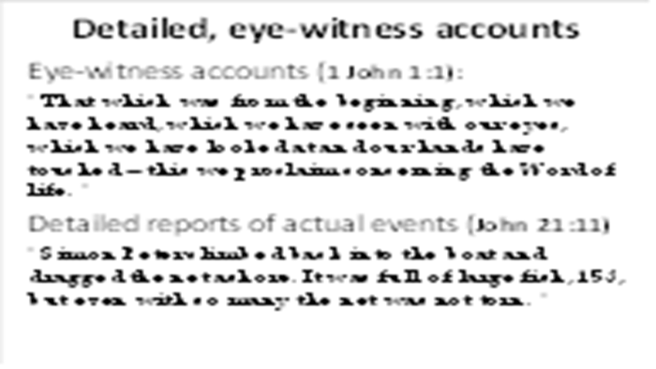 | The Bible is amazing in that it was written either by eye-witnesses or first-person interviewers, not handed down over centuries of generations.
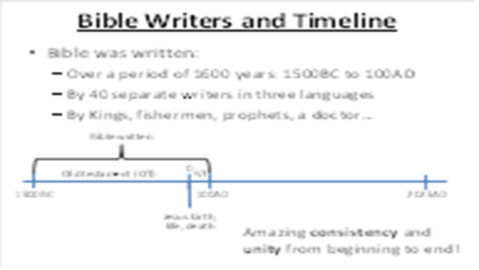 | One of the most amazing things about the Bible is the consistency displayed from beginning to end. If you examine a book written by 40 different writers over a period of 1600 years and find that it contains amazing consistency, you know that it must be more than a human creation.

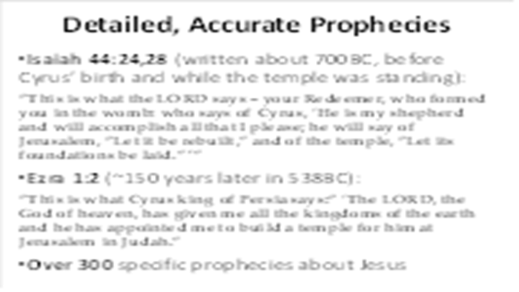 | The Bible is unique in that it is the only religious book that makes specific detailed prophecies about the future. While some books make general statements (e.g. there will be wars and earthquakes), the Bible actually describes places, names, and dates.  Another example is found in Daniel 9:25,26 which was written about 600BC. It predicts that 483 lunar years would come between a decree to rebuild Jerusalem and the arrival of Messiah. We then see the actual history in Nehemiah 2:1,6-8 when King Artaxerxes writes decree in 444BC. Historical records show that Jesus rode into Jerusalem in 33AD.
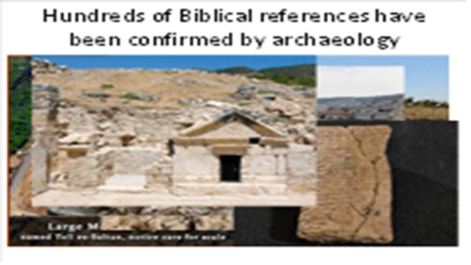 | Archaeology is a relatively new science, only several hundred years old. For many centuries, people questioned the existence of the cities described in the Old Testament. But now, the Bible is used as an archeological guidebook to help them find what they are looking for.
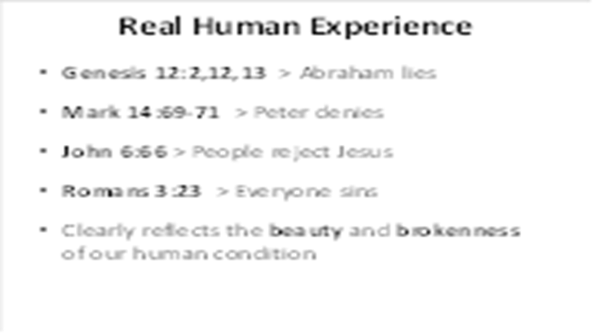 | “Principle of Embarrassment” = if the text is embarrassing to the author (or main character?), it is probably true
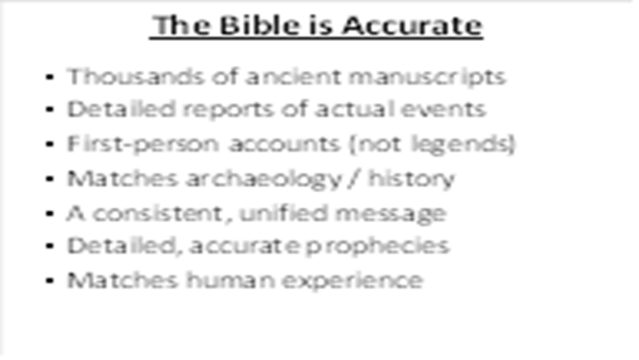 | Unlike many religious books, the Bible does not simply provide a list of rules to obey. It contains true stories of history, showing how God created people, how they broke away from Him, and what He has done to bring them back to Himself. The detailed accounts of the Bible are characteristic of actual historical reporting (not mere fiction). And other than Jesus, the heroes of the Bible are realistically portrayed, including their mistakes and failures.
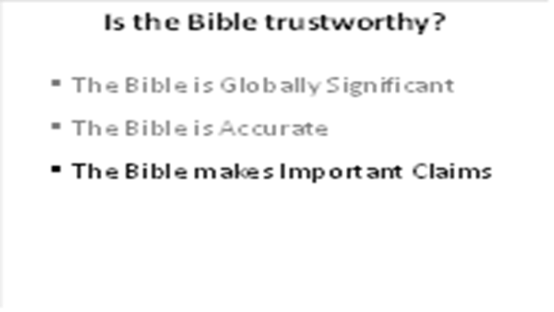 | Perhaps you’ve heard some things about the Bible. Many people think that the Bible is just a book of Legends or that it is like many other religious books – filled with rules and philosophy. Tonight, I want to clarify what the Bible really is and why it’s worth studying.
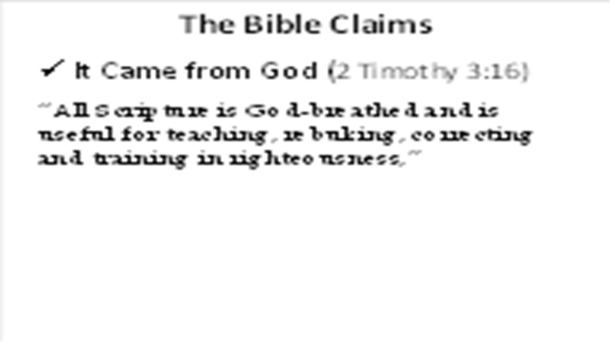 | Also, 2 Peter 1:21
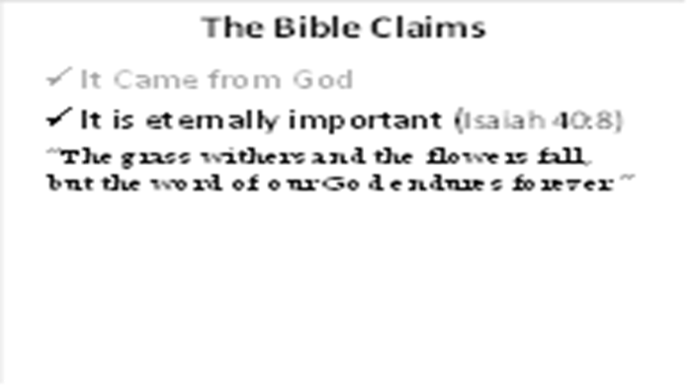 | Also Matthew 24:35
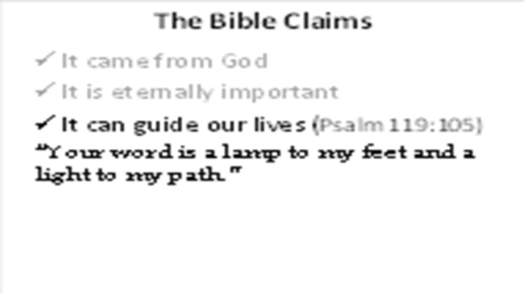 | Hebrews 4:12 also states that the Bible “alive”: “For the word of God is alive and active. Sharper than any double-edged sword, it penetrates even to dividing soul and spirit, joints and marrow it judges the thoughts and attitudes of the heart.”
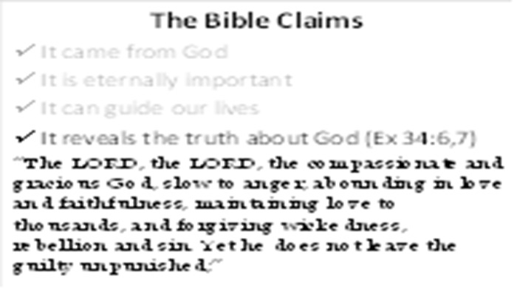 | Also Jeremiah 9:23,24 and Hebrews 1:1-3
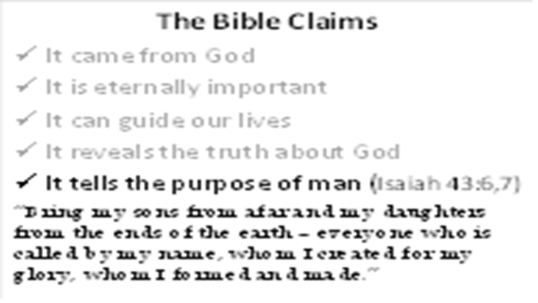 | Also Psalm 103:11 and John 1:12
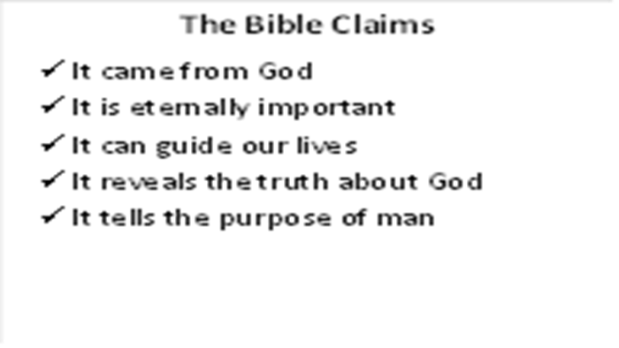 | If these claims are true, The Bible is absolutely worth studying. But even if they are not true, it is important to know the central message of the most popular book in world history!
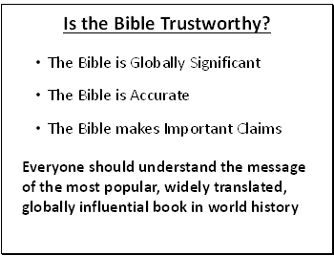 | In the Bible, there is a story of one brother (Philip) who discovered the truth about Jesus and told his brother (Nathanael) about Him (John 1:44-51). Nathanael was skeptical, so Philip gave him a simple invitation: “come and see.” This is my invitation to you about this Bible study series: “come and see for yourself.” We won’t try to force anything on you and will do our best to answer any questions that you might have. When I finally understood the truth about the Bible, it changed my life. And I hope it does the same for you!

