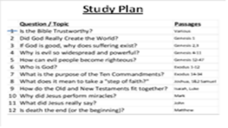
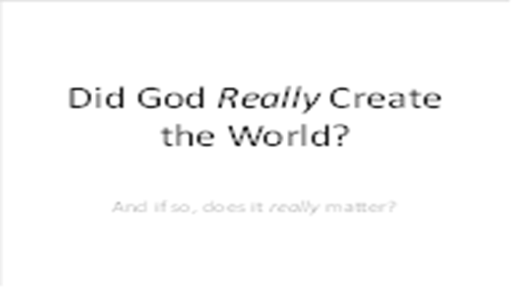 | Today's lesson is a very important topic in our study. Did God really create the world or is everything here all by accident?
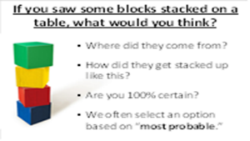 | Imagine you came into my house and saw these blocks stacked up on a table. Then I asked you where the blocks came from and how did they get stacked up like this. What would you say? Are you 100% certain? You didn't see it happen, but you made a judgment based on what seems most probable. We often make judgments based on “most probable,” even though are not 100% certain.
 | Imagine you're working in a hospital and a man comes into the clinic with chest pain. You are the doctor and need to make a decision about what to do. What do you think this man's problem is? What will you do next? Your decision may determine his life or his death. Are you 100% certain about his problem? Sometimes, you need to take action even though you don’t have 100% certainty.
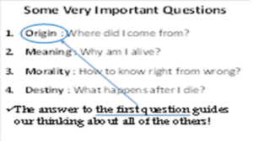 | In life, we all need to answer four very important questions:  2. Meaning: is there purpose for my life? Why am I here?  3. Morality: how do I know what's right and wrong and how can I tell the difference?  4: Destiny: what happens after I die? Do I just disappear or is there something else?  Our answers to these questions are all based on the very first question –  1. Origin: where did I come from?  The answer to this first question guides our thinking about all of the others.
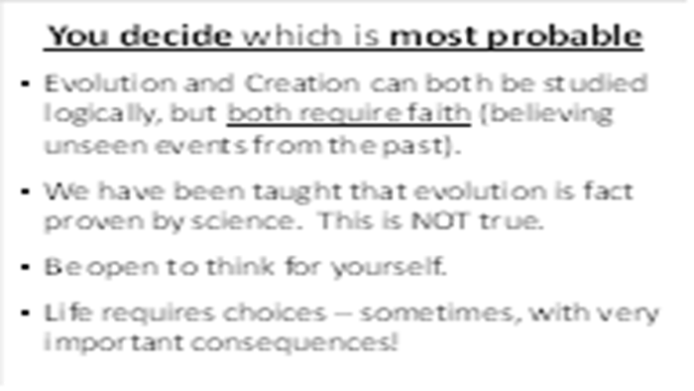 | If you are like me, you heard a lot about evolution in high school and college. Evolution and Creation are the two possible explanations for our origin. Both of them can be studied logically, but both of them require faith, because they are based on things from the past.  In school, we were taught that Evolution is a proven fact of science. But this is impossible. For the scientific method to work well, things must be observable, measurable, repeatable. Since the origin of the universe and existence of life don’t fit those possibilities, we must use the evidentiary method, asking questions like a detective seeking clues and looking for consistency of testimony, relevance, authenticity, trustworthiness, etc.  Today as we discuss this topic please be open to think for yourself. Because life requires choices and sometimes those choices have very important consequences.  As with many important decisions, we will approach it seeking what is most probable, not absolutely certain.
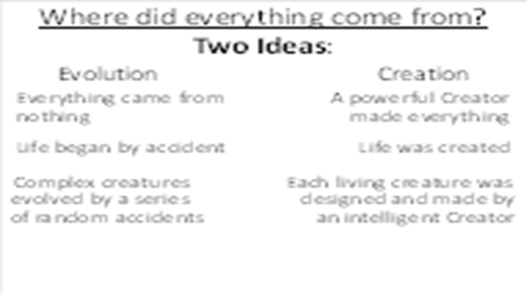 | We could spend many hours discussing this topic, but today we plan to discuss just three aspects of this topic. As we do I want you to think about each one, asking whether evolution or creation is most probable.
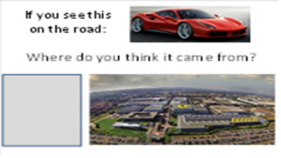 | First of all, imagine you're driving down the road and you see this red sports car go by. Where do you think it came from? An empty space of nothing, or a Ferrari factory?
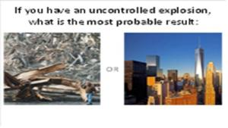 | The next question: if you have an uncontrolled explosion, what is the most probable result: the picture on the left or the picture on the right?
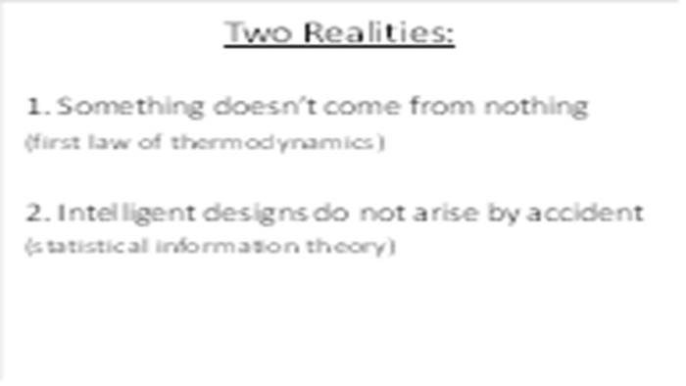 | Your ideas are reasonable because we know two realities:  First – things don’t instantly appear from nothing. This is defined by the first law of thermodynamics  Second – intelligent designs do not arise by accident – they need an intelligent source. This is expressed by statistical information theory.
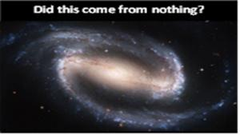 | With that in mind, if you look through a powerful telescope and see a spiral barred galaxy like this, would you assume that it came from nothing?
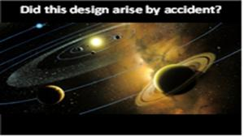 | When you look at the solar system in which we live, with the balance of planets and moons, do you think this design is here by accident?
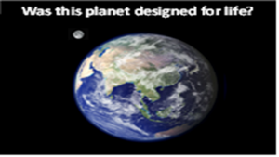 | Consider the planet Earth with its water, atmosphere and perfectly balanced moon. I think that you will quickly decide that this special planet was designed for life.
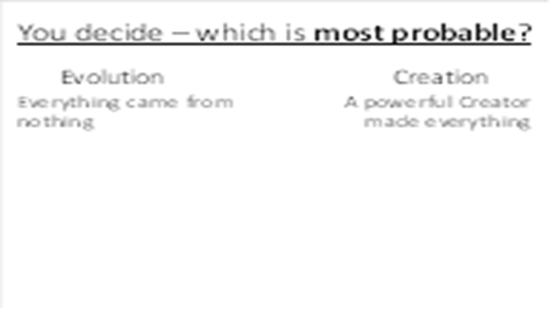 | So, between these two options, which seems most probable to you? Everything that exists came from nothing, or a powerful Creator made everything?
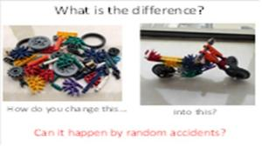 | Look at these two pictures. What is the difference between the picture on the left and the one on the right? If you said they are the same, you are partly right. Both pictures have the same pieces. But the one on the right has all of the right pieces put into the right places. How do you change the picture on the left into the picture on the right?
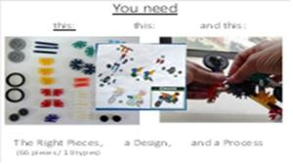 | To change the pieces on the left into the motorcycle, you need several things: you need the right pieces (there are 66 pieces of 19 different types), you need a design, and you need a process to follow that design and assemble the pieces.
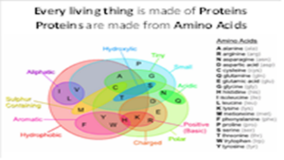 | Every living thing is made of proteins. And proteins are made from amino acids. This is a simple picture of a protein and the amino acids from which it is made.
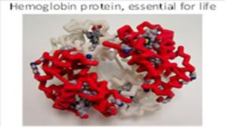 | This is a model of hemoglobin, a very important protein essential for our life.
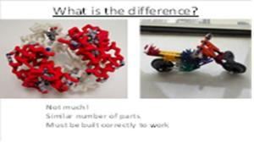 | What is the difference between the hemoglobin protein and the motorcycle I showed you earlier? Actually, not much. They both have a similar number of pieces which must be assembled correctly in order to work.
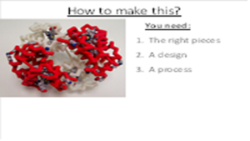 | How would you make a hemoglobin protein? Just like the motorcycle, you need the right pieces, you need a design, and you need a process.
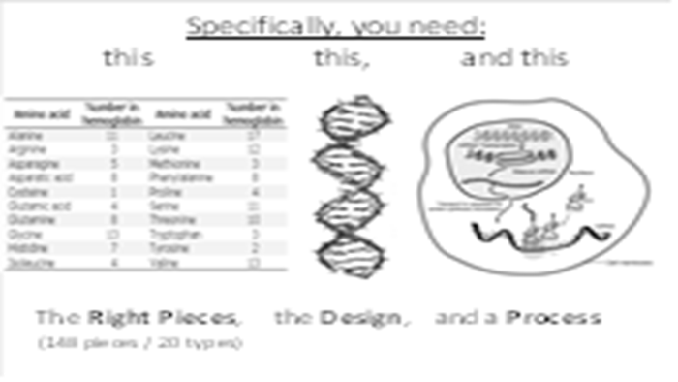 | Specifically, you need 148 pieces of 20 types. And you need a design – one that we call DNA. And you need a process to put all of the amino acids into the right places, one that is called RNA synthesis, a process that proceeds at amazing speed.  All of these things are required to make a hemoglobin protein necessary for life. The hemoglobin protein is complicated, but not the most complicated protein in your body.
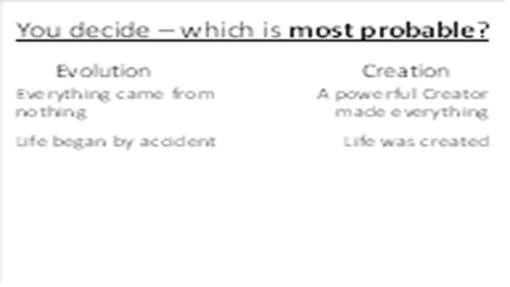 | So, which seems most probable? Life all began by an accident: all of the parts magically appeared at the same time, assembled themselves in exactly the right positions, and began to create additional copies of itself? Or was life created by an intelligent source?
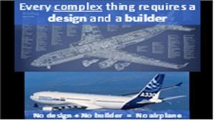 | We all know that every complex thing requires a design and a builder. This Airbus A330 aircraft will not come about unless there's a good design and all of the pieces put together by engineers and builders. You would not want to fly on this airplane unless it was well designed and built by very smart people.
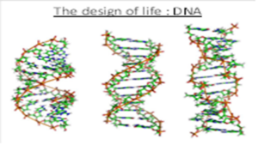 | The design for life is DNA. Every cell of your body has a copy of what's necessary to make other cells of your body. This design is so complicated it would take books stacked from floor to ceiling in order to contain all of the same information.
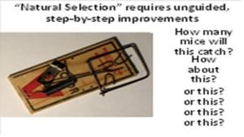 | Evolution requires “natural selection.” This means that step-by-step changes occur and each step along the way improves the function of the organism. So let's do a “thought experiment” to test how this might work.  This mouse trap starts with a wooden base. How many mice would this one piece of wood capture? (none)  Next, if I add a hammer, how many mice will this capture now? (none)  How about if I add a spring? (none)  What if I add a retainer wire? (none)  What if I add a trigger? (none)  I think you see what I mean. Each simple step does not make this more effective at catching mice. Unless the whole trap is assembled at one time it will catch no mice.
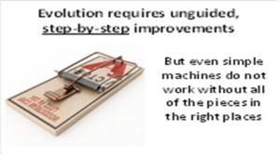 | This mousetrap is a very simple machine. But even simple machines do not work unless all of the right pieces are in the right places. We call this “irreducible complexity.” And we see this exact same thing in every living creature. Let me show you an example in our human body…
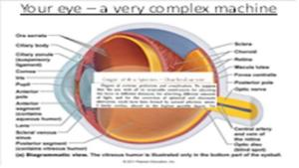 | This is a diagram of your human eye. There are 66 major parts to everyone's eyeball. All of the parts must be in the right place and working properly have any vision. It cannot evolve, step-by-step over time by natural selection. (And I haven’t included the complex brain network to process images).  Charles Darwin who wrote the “Origin of the Species” said that it is “absurd in the highest possible degree” to imagine such a thing developing by natural selection.
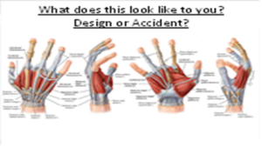 | Look at this sketch of a human hand. Look at the tendons, the muscles, the channels and little pulleys. Does this look like something that accidentally evolved, or does it look like a design to you? Engineers will tell you that artificial hands are some of the most difficult parts of a robot to design and build.
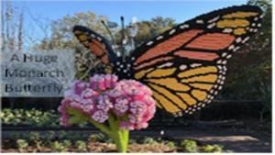 | I was with my grandchildren at our local zoo last year. There was a display where someone had built this huge monarch butterfly out of Lego Blocks. Do you think that all 60,549 of those Lego pieces could possibly have come together all by accident?
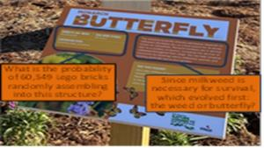 | Also, for monarch butterflies to survive, they need a food source. The food for monarch butterflies is called milkweed. Without milkweed monarch butterflies will not survive. But without butterflies, milkweed will not propagate. Do you think that this creature and the plants evolved together step-by-step?
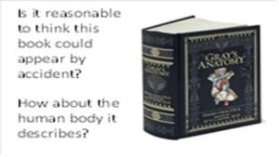 | This is a copy of the most famous anatomy book used by medical universities. Gray's Anatomy has thousands of sketches of every part of the human body. Do you think it's reasonable that this book could appear by accident? Could there be an explosion in a printing shop, and all of the ink and paper flies around until it comes together and this book is accidentally created? How about the human body that it describes? It is much more complex than the book.
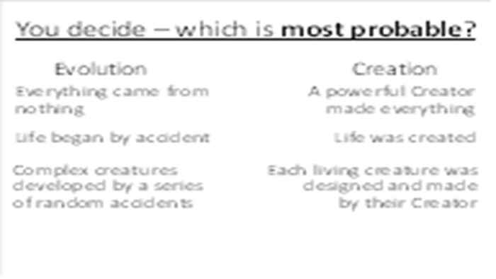 | Finally, the third question – which is most probable: complex creatures developed by a series of random accidents, or that every living creature was designed and made by their Creator?  By these three simple tests, creation is a much more probable option than evolution for the origin of people.
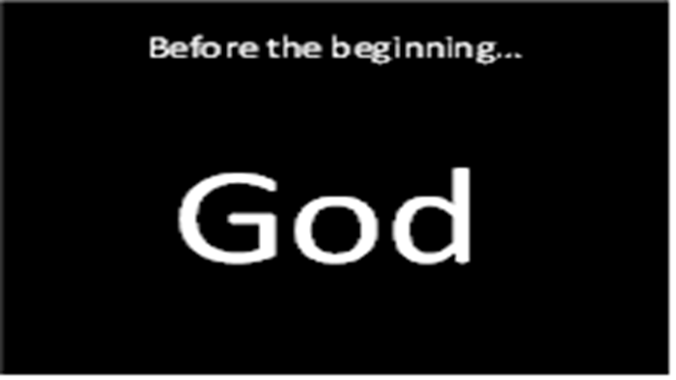 | Before the beginning, there was no planet Earth, no stars, no universe – only God. Remember – He is the central figure of everything (not us).
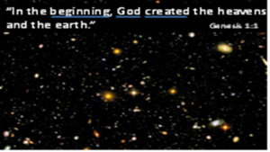 | And God made a choice – a choice to create us, a planet on which we can live, and a universe surrounding the planet. Remember – It is His universe and we are His creatures.  This first verse in the Bible tells us three important things:  A beginning – the Bible stated this long before science proved it to be true (and while other religions claimed the universe was eternal)  God – He existed before the beginning and is the source of everything that exists.  He created – the universe came into being by His choice, not by some cosmic accident
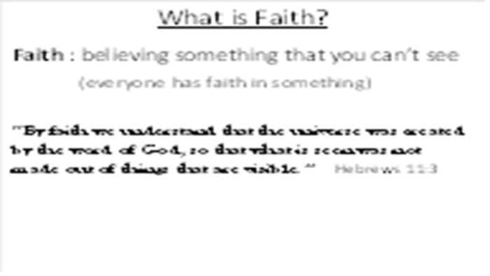 | The Bible talks a lot about faith. Faith is believing in something that you cannot see. We all have faith in many things. Every time you eat food in a restaurant, you have faith that the cook has prepared it in a way that's safe to eat. Every time you get on an airplane and buckle your seat belt, you have faith that the pilot can safely transport you from one airport to another. Faith is a natural and important part of life.  The Bible says that by faith we understand that the universe was created by the word of God. In His power, God created the things that are seen out of things that are visible. Basically, the Bible is saying that God created the physical matter of the universe using His own invisible energy. And we now know that this is reasonable and scientific by the special theory of relativity (E=mc2). So let's go to the first book of the Bible and see what it says about creation.
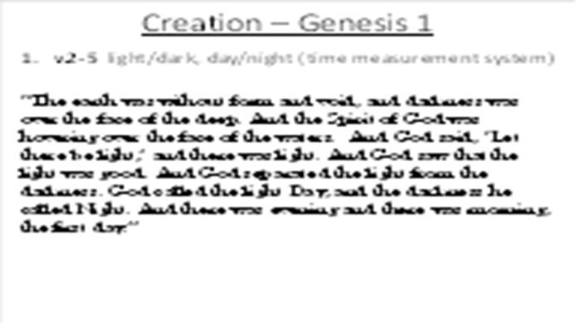 | In verses 2 through 5, God speaks powerfully into the darkness, bringing light from His own glory. He takes an earth that is without form and creates a stable, rotating planet, creating the day/night cycle, allowing us to keep track of time. The first “day” begins and ends.
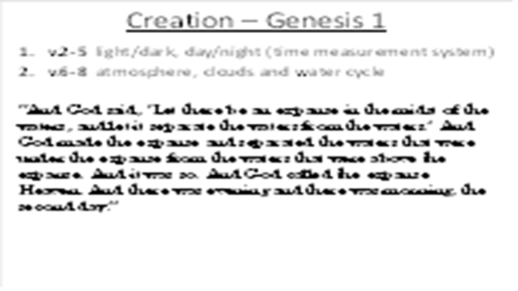 | On the second day, God separates some of the water on the surface of the planet and layers of water and gases in a protective canopy around the earth. This will be important to protect living creatures from the radiation of the sun. The earth is very unique among planets in that it has a very perfectly balanced atmosphere for plants and animals to survive.
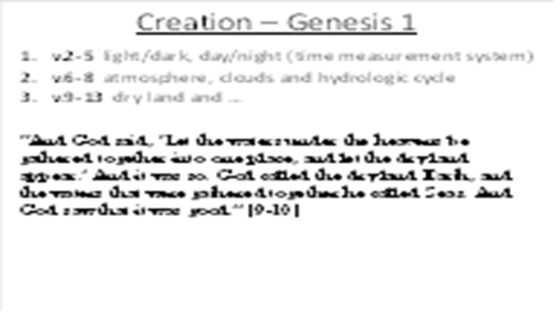 | On the third day, God lifts up dry land from the water-covered world, creating continents and seas.
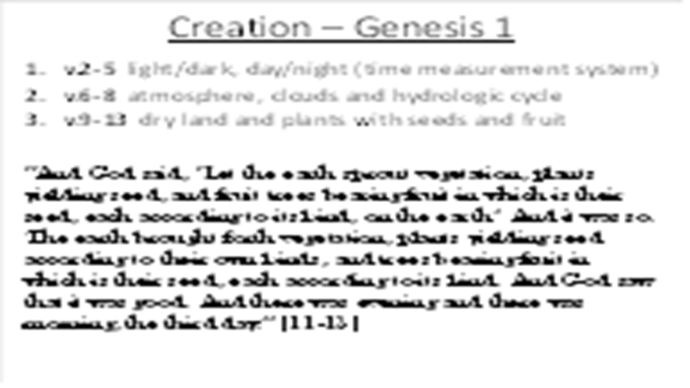 | On day three, He also creates plants with seeds and fruit. A seed is a very complicated thing, containing everything required to produce a duplicate of the original plant.  Some people wonder if these early earth days are the same as our current 24-hour days, thinking that the earth looks too old for such a short creation period. But remember: God created trees with fruit and seed, trees that are actually only one day old, but have an “apparent age” of many years.
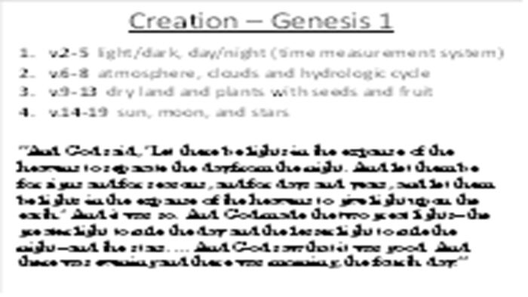 | On the 4th day God created the sun, moon and stars. You might wonder where the light came from on day 3 for photosynthesis in the plants. On the first day God created light, but it didn't come from the sun. Where did it come from? It came from God himself. And by creating an orbiting moon, God stabilized earth’s rotation and created tidal cycles.
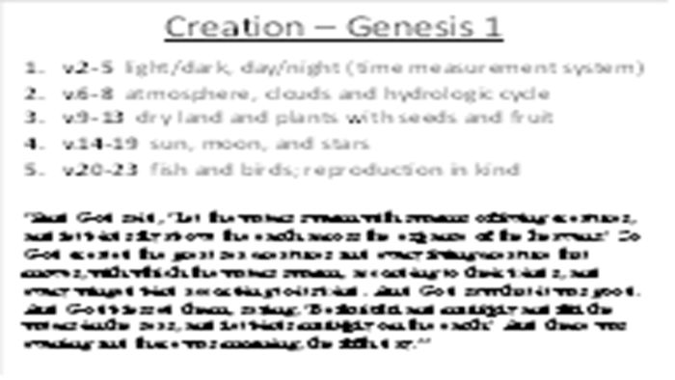 | On the 5th day God created fish and birds, giving them the ability to reproduce according to their “kind.” The word “kind” is the same one that we use for “species.” What is God saying? He is saying that He created every species unique and genetically designed to stay true to its species. He didn’t create a simple organism and start the process of evolution. And this is exactly what we find in the geologic record, a period of time known as the “Cambrian Explosion” when all species are found originating at the same time.
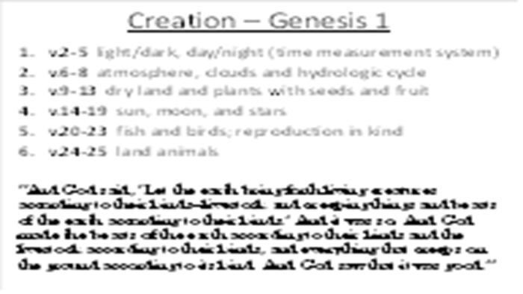 | On day 6 God creates land animals. Again, he creates them all unique and designs them with ability to reproduce according to their individual species.
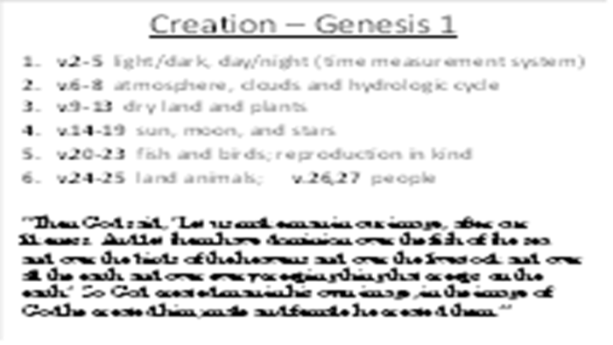 | On day six God also does His most amazing work of creation – He creates people. But He doesn’t make people like all of the animals – God creates people in his own image. What does that mean?
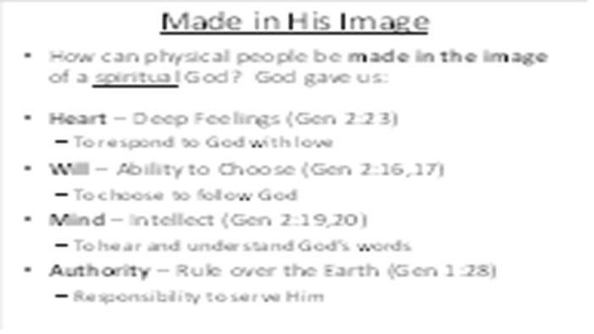 | Since God is a spiritual being, how can He create physical people in His image? When God created people, He gave us at least 4 attributes similar to His own:  He gave us emotions – we say that He gave us a “heart.” This gives us the ability to respond with love to Him. He gave us a “will,” the ability to make choices. Because of our will, we can choose to follow him or reject him. He gave us a “mind.” With our mind, we can hear and understand His words and we can get to know Him.  He also gave us “authority,” giving us the ability and responsibility to rule the earth and serve him.  Perhaps God has given us these four attributes so that we can fully love Him – “And you shall love the Lord your God with all your heart and with all your soul and with all your mind and with all your strength.” Mark 12:30
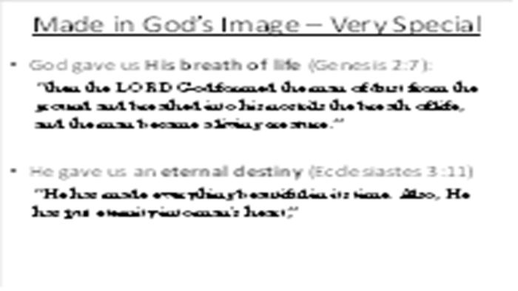 | Since we are made in His image, He also gave us two very important things different than animals”  He personally formed us from the dirt and breathed into us the breath of life. This is not just a breath of physical existence – it is a spiritual breath of life from the spiritual God.  He also put into our heart a sense for eternity. This is why all over the world, people are trying to figure out how to live beyond death. Animals don't care about this, but we do.
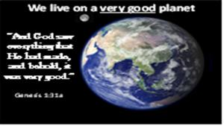 | In summary we live on a very good planet.
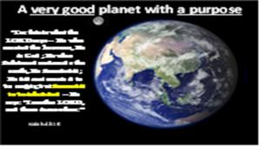 | And this planet was created for a purpose. It was created to be inhabited by people, people who can know and glorify God.
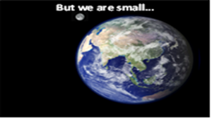 | But this planet is actually a very small place.
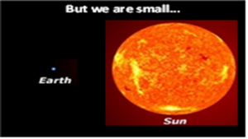 | Compared to the sun it seems like just a small dot.
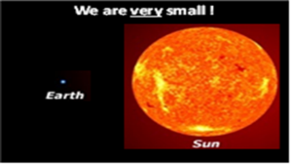
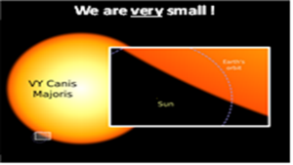 | But our sun is a small dot compared to a large star like VY Canis Majoris.
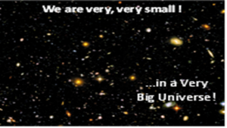 | Even our Galaxy is a very small dot in the whole universe. I love this picture from the Hubble Space Telescope of a single shot into outer space showing thousands of galaxies.
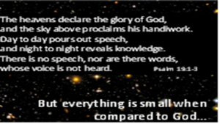 | The Bible describes the universe in this way in Psalm 19. Some people wonder why the universe is so large with so many galaxies. But the Bible is clear dash-God made the universe to give him glory.
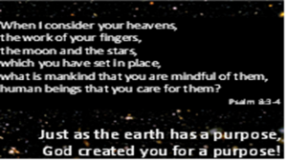 | But in a universe so large, does God really think about you and me? This is where the Bible helps us understand. Even though He reveals His glory through creation, He reveals something extra through the Bible. He tells us that He thinks of each one of us. That's the beauty of the Bible and creation. That is one of the important purposes of the Bible – it reveals our purpose!  We see the glory of His powerful creation and we hear about the glory of His personal love. He is truly the God of our worship and attention.
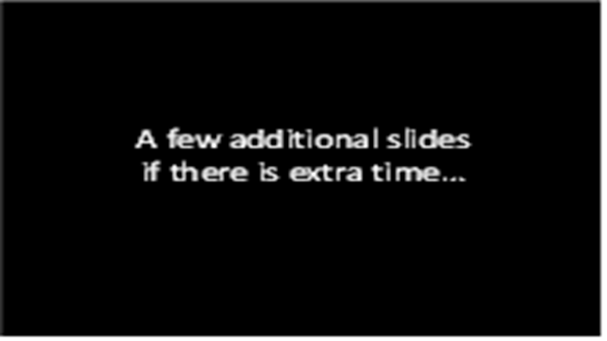
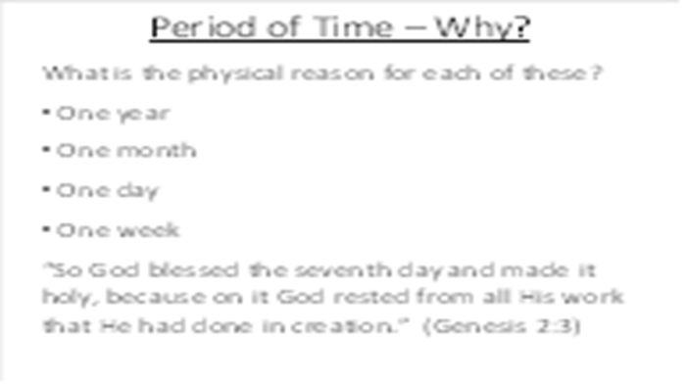 | As we proceed down this page, we find that each measurement of time has a physical reason for existence:  One year = the time it takes the earth to go around the sun  One month = the time it takes the moon to go around the earth  One day = the time it takes the earth to rotate around itself  But when we get to one week, there is no clear physical reason for this. The only explanation for this global measurement of time is found at the end of the Biblical creation story in Genesis 2:3.
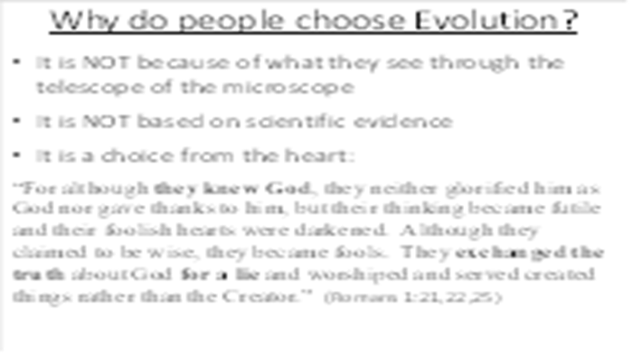 | People might wonder why so many people actually believe in evolution. Sadly, we were taught it in school as though it is a scientific fact, so we just accepted evolution based on the “experts.”  Many “scientists” choose to believe evolution because it frees them from the authority of God. They no long feel a need to submit to Him as the ultimate law-giver and judge. Other people working in the academic world accept evolution because it has become the only acceptable option in their culture.  Aldous Huxley (the grandson of Thomas Henry Huxley, “Darwin’s Bulldog”), did not adopt evolution because of scientific observations; he famously admitted it offered a philosophical justification to escape traditional morality. In his 1937 book “Ends and Means“ he wrote “I had motives for not wanting the world to have a meaning... The philosophy of meaninglessness was essentially an instrument of liberation from a certain system of morality. We objected to the morality because it interfered with our sexual freedom."
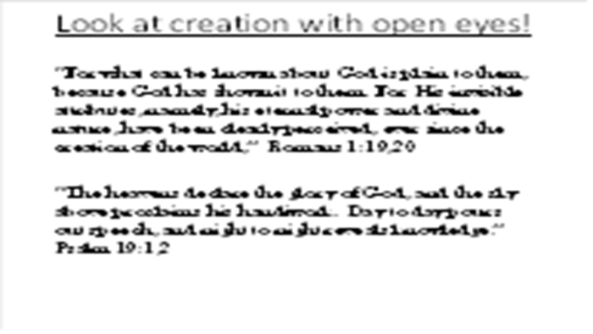
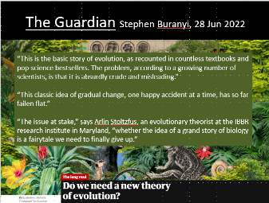 | I regularly see new articles like this, casting strong doubt on evolution as a theory of origin, suggesting that we need to find something that better fits with the evidence.

